**Flow Charts and Pseudo Codes**

**1) Steps to Solve a Given Problem:**

* Understand the Problem.
* Given Values & Variable Ranges.
* Approach (Flowchart & Pseudocode)

**2) Flow Chart:**

Flow Chart is the diagrammatical representation of a solution.

**3) Pseudo Code:**

Pseudo Code is the textual representation of a solution. It is a general way of representing a logic.

**4) Element of a Flow Chart:**

The elements of flow chart are as follows.

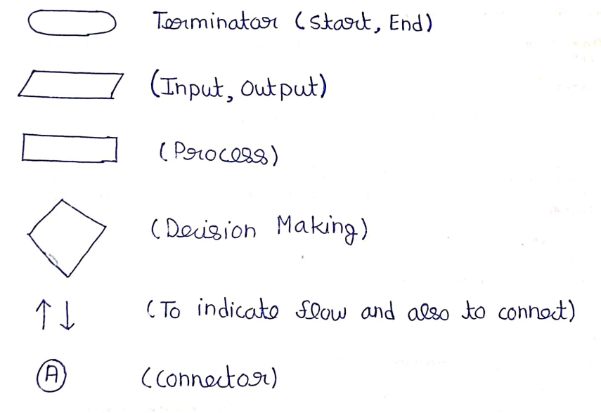

**Question 1:**

Sum of two given number a and b.

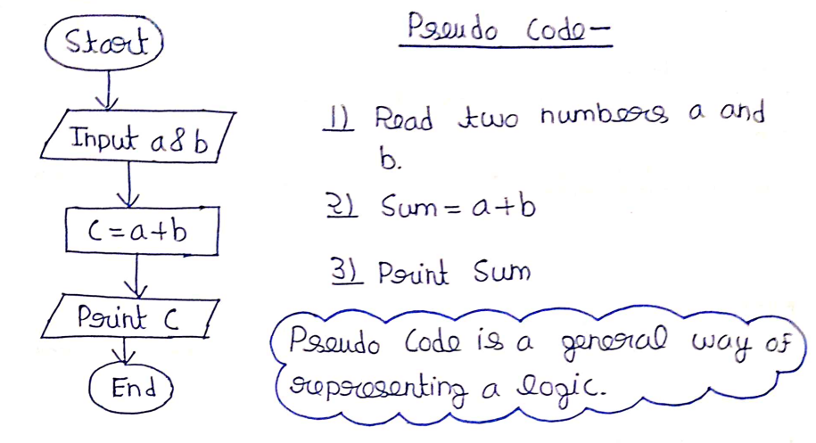

**Question 2:**

Calculate the Simple Interest.

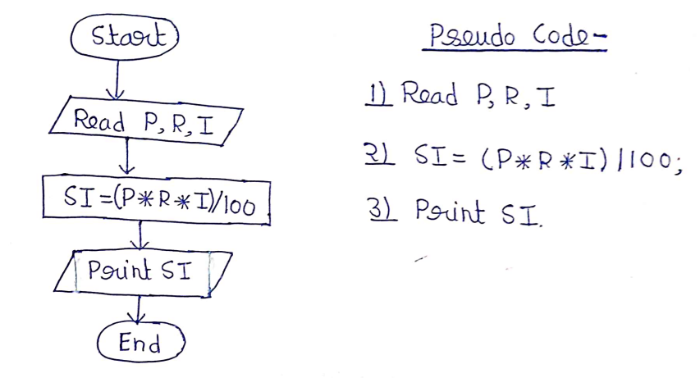

**Question 3:**

Calculate the average of three numbers.

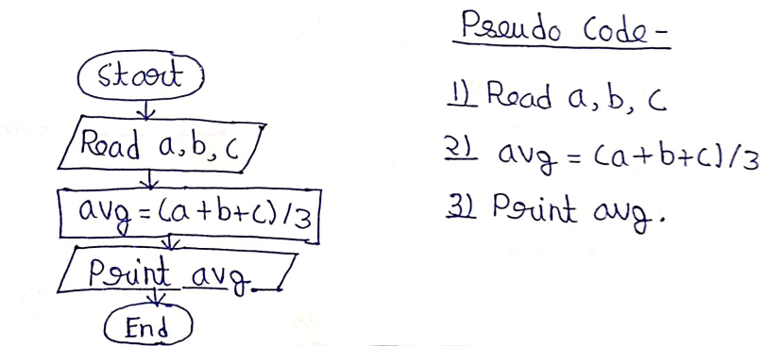

**Question 4:**

Check if a number is greater than other number or not.

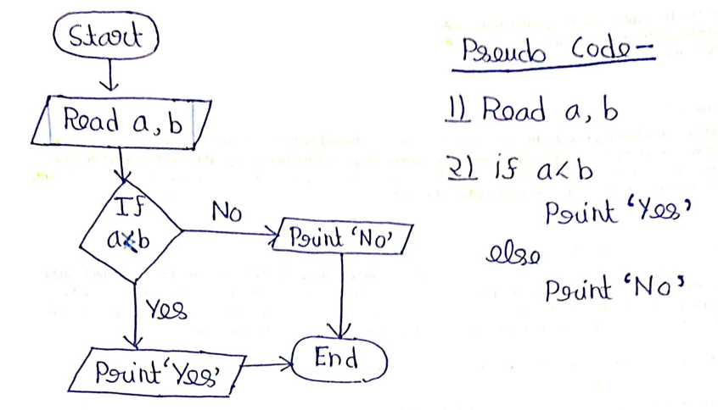

**Question 5:**

Check if a number is even or odd.

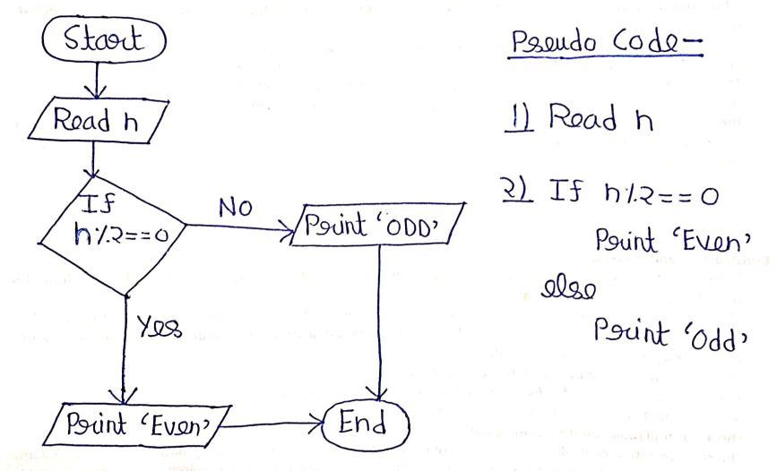

**Question 6:**

Check if number is positive, negative or zero.

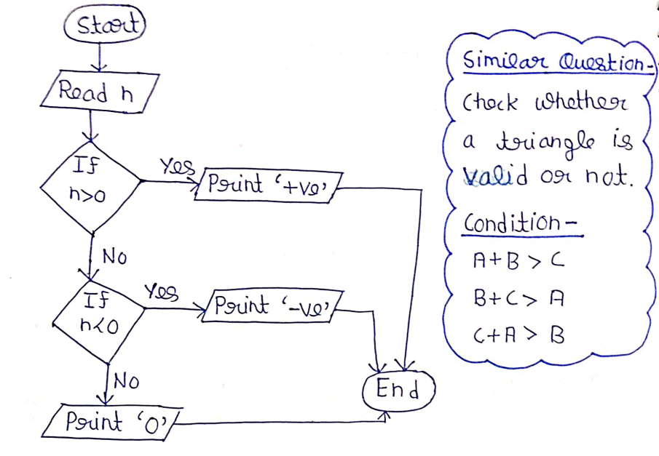

**Question 7:**

Check if a triangle is valid or not.

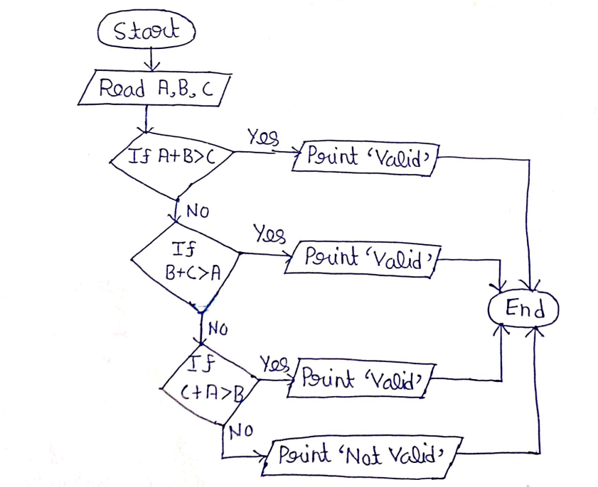

**Question 8:**

Print number from 1 to n.

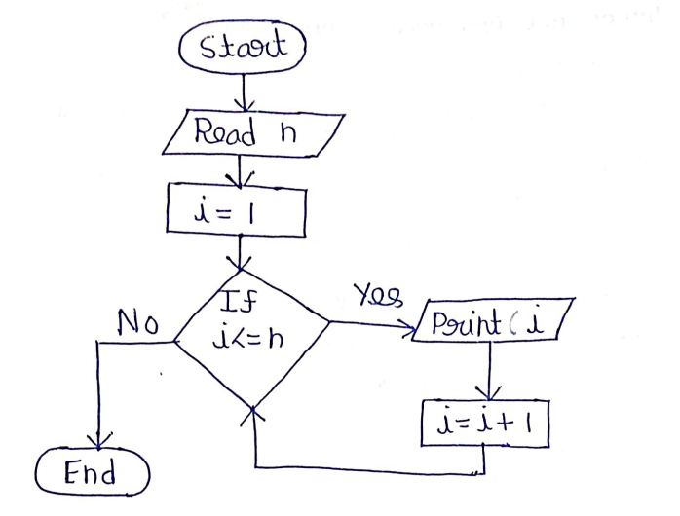

**Question 9:**

Find sum from 1 to n.

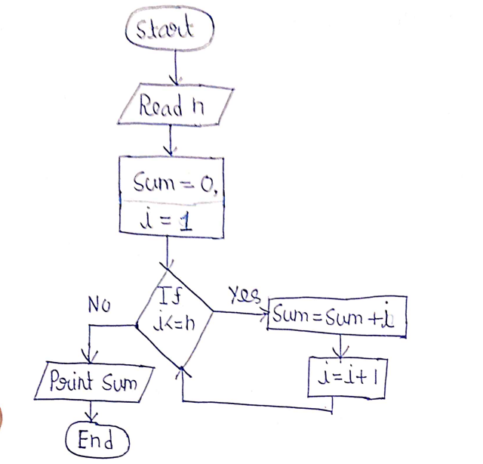

**Question 10:**

Find the factorial of a number.

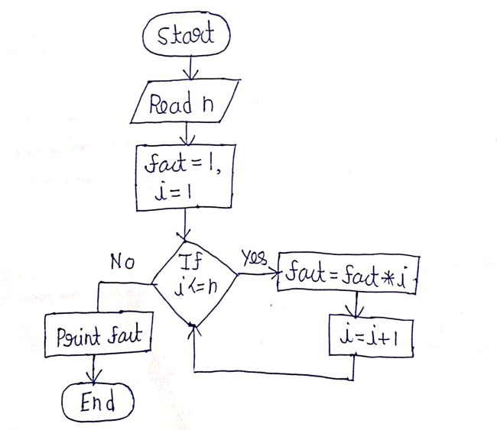

**Question 11:**

Check if a number is prime or not.

